Rapid Assessments: Companion Guide

Introduction
States have diligently responded to the COVID-19 crisis with flexibility, creativity, and strength. In response to the pandemic, states have created leadership teams, identified populations most in need, responded to workforce capacity and safety issues, and continued providing essential services, to the degree possible.
This tool serves as a checklist to help NWD Systems assess their current operations and adapt to meet new needs arising from the COVID-19 pandemic or similar emergency situations. The overarching goal is to align the workforce to provide services most helpful for people in need. This assessment can help NWD systems identify organizational steps needed to respond to COVID-19, as well as to recover from COVID-19, to mitigate barriers, and to prepare for future outbreaks.
This package includes four sections, each focusing on a different aspect of NWD System crisis response:
- Establishing a rapid response team and response plan, and assessing IT and communications (Items 1-10),
- Assessing people in need of NWD System supports, available services, and workforce (Items 11-13),
- Modifying the services available to address identified needs (Items 14-20), and
- Appropriately adjusting the workforce to provide the services people need (Items 21-24).

Who should complete the rapid assessments, and when?
NWD System entities at the state and/or local level can complete the rapid assessment. It is recommended that each state or local entity initially complete all four sections of the rapid assessment. For the ADRC COVID-19 grant, each state/territory must submit at least one assessment to ACL before June 30, 2020. These submissions will help ACL provide support as needed and effectively target technical assistance. Rapid assessment submissions may come from the state or local level. As appropriate, states and local sites may choose to periodically reassess to identify gaps in people who receive and/or need help, the services they need, and the capacity of the workforce to meet those needs. States may also choose to share these re-assessments with ACL.

What information is needed to complete the rapid assessment?
Gather Information | When starting the assessment, it will be useful to have the following available:  - Emergency Preparedness Plan  - Any state specific declarations and guidance  - Pre- and post-COVID-19 data from information, referral, and assistance (IR&A) and person-centered counseling (PCC) calls, such as:  - Individuals receiving NWD System services  - Individuals calling the NWD System toll-free number for the first time who may remain on NWD System caseloads  - High-level descriptions of the pre-COVID-19 services the NWD agencies deliver  - Areas in the state that have been most heavily impacted
Talk with Partners | As you complete the assessment, it may help to talk with the following people and organizations. It may be helpful to collaborate with many of these groups when developing your strategy and as responding to COVID-19.  - ADRCs and partner organizations providing direct services to individuals or providing pre-COVID 19 services in congregate settings  - COVID Response Leadership Team, including State Medicaid Agency, State Unit on Aging, and other state health agencies  - Hospitals  - Nursing facilities  - LTSS community-based service providers  As you gather information, it will also be helpful to talk with individuals in the target population and their caregivers.

Review your assessment findings
Each assessment includes a series of items; check “yes”, “no”, or “in progress”, or “not applicable” to indicate whether your state or local site has accomplished that item.
- Yes: The state or local entity has fully completed the item
- In Progress: The state or local entity has partially completed the item
- No: The state or local entity has not begun completing the item
- Not Applicable: The state or local entity does not plan to address the item, or the item does not apply to the state or local operations or structure
For each question, there is no “right” or “wrong” answer; ACL does not expect that states will have completed all items. Instead, this assessment is meant to foster state and local reflection and lead to positive action, when appropriate. There are links and promising practices throughout the assessments to help you address certain items. You may also reach out to ACL for further assistance. Because states have limited resources and capacity, it may not be feasible for states to fully complete all items on the checklists. However, the items are suggestions and starting points for dialogue around effective COVID-19 response.
ADvancing States has also compiled a list of COVID-19 resources and guidance from state health departments and agencies. This repository could be helpful to identify practices from other states that you may want to emulate.

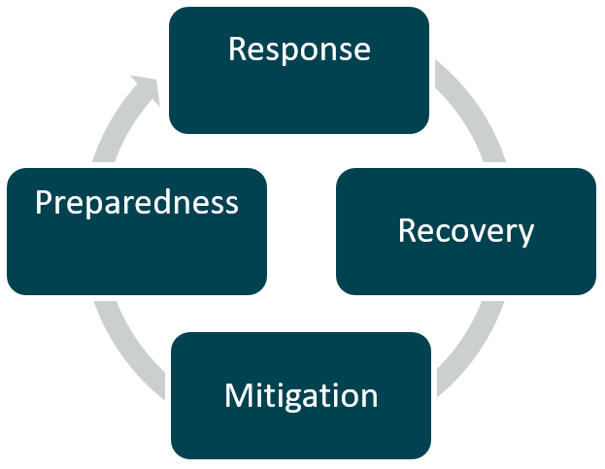
What’s next?
Responding to a pandemic requires a strategy which includes four phases of emergency management: response, recovery, mitigation and preparedness. The majority of this rapid assessment includes considerations for the response phase as most of the country grapples with the impact of active disease and social distancing measures. States will also need to consider how they will mobilize for recovery, mitigation, and preparedness. Section 1 of this assessment addresses considerations for the recovery and mitigation phases.
You may also find the Capacity-Building Toolkit for Aging and Disability Networks in Emergency Planning helpful as you consider the four stages of emergency management. This toolkit was developed through a collaboration across The National Association of County and City Health Officials (NACCHO), the Association of State and Territorial Health Officials, the Assistant Secretary for Preparedness and Response, and ACL.

